FACULTY OF COMPUTER AND INFORMATION TECHNOLOGY

SOFTWARE ENGINEERING DEPARTMENT   
COURSE NAME : SYSTEM ANALYSIS AND DESIGN   
**DISASTER MANAGEMENT APPLICATION**   
SUPERVISED BY DR. MALIK QASAIMEH

|  |  |
| --- | --- |
| **Student Name** | **ID** |
| **Ghada Ziad Musallam || Section 1** | **144155** |
| **Rama Omar Dalgamouni || Section 1** | **140119** |
| **Rana Ahmed Hazaimeh || Section 1** | **145419** |
| **Shefa'a Elayan Alkhatib  || Section 2** | **144751** |

**Table of contents:**

1.planing phase1:

  1.1.Scope...........................................4

   1.2.Context Diagram..........................5

  1.3.Risks.............................................6

  1.4.Feasibility Study...........................7

  1.5.Sechedules..................................12

**1-1.Scope of Disaster Management Application:**

Disasters are something that we cannot stop. However, with the help of cutting-edge technology we can very well predict it and reduce the destruction caused by it. Moreover, we can save lives with the help of a warning. So, we work to develop a mobile app that automatically gives alerts to its users warning them of a possible natural disaster.

Moreover, the app also helps its users who are stuck in a perilous situation. The users simply must send a request stating information like location, and other important details. The request will be received by the operator who will assign the rescue duty to the nearest disaster management executive. The executive will then go to the location and rescue the user.

**1-2.Context Diagram**

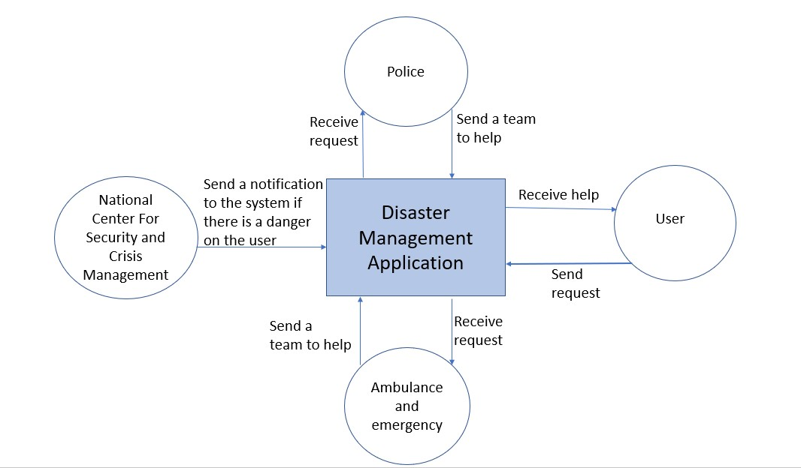

**1.3. Risks:**

1-Lack of experience, which leads to many errors.

2-Continuous climate change.

3-The presence of the application user in a mountainous area that does not contain a signal, which affects the use of the device.

4-The occurrence of disasters in a residential area, which leads to the difficulty of evacuating the area.

5-Potential Risk of Security Violation.

6-The conflict among stakeholders regarding the functionality.

7-Changes are inevitable.

**1.4. Feasibility study:**

**Technical feasibility:**

       Due to the large number of disasters that can occur in a particular area, we have developed an application that deals with news platforms responsible for predicting and publicizing these disasters to warn people of them.

      A notification is sent to system users. This notification conveys news of the disaster that will occur in the area where the system user is located. The user of the system can also request the help he wants through this system, and this help will be about the damage that may result from the disaster that occurred. So that the user of the system determines the place and type of assistance he wants to reach the appropriate party.

**Economic feasibility:**

Developing the system will be easy, that's why we don't need any training sessions.

In addition to that, the system developers have sufficient skills, we do not need any other developers.

Most important of all, its development does not require a lot of resources.

|  |
| --- |
| Tangible benefits worksheet: |
| ________________________________________Year 1 through 5__   1. Cost reduction or avoidance $ 4,000 2. Error reduction 2,300 3. Increased flexibility 7,350 4. Increased speed of activity 9,900 5. Improvement in management   planning or control 26,000   1. Other____________________________ _____0   Total tangible benefits $ 49,550 |

|  |
| --- |
| ONE-TIME costs worksheet: |
| ________________________________________________Year 0__  1.Devlopment costs $ 15,000  2.New hardware 5,000  3.New (purchased)software, if any  *Packaged applications software 4,500  *Other_______________________________ ____0  4.User training___________________________ ____ 0  5.Site Preparation 2,000  6.Others________________________________ ____0  Total one-time costs $ 26,500 |

|  |
| --- |
| Recurring costs worksheet: |
| ________________________________________year 1 through 5___  1.Applicayion software maintenance $ 20,000  2.Incremental data storage required:  20GB * $50 (estimated/MB = $50) 1,000  3.Incremental communications  (Lines, messages, …) 1,500  4.New software or hardware leases 1,000  5.Supplies 890  6.Other________________________ ___0  Total recurring costs $ 24,390 |

**1.5. Gantt chart**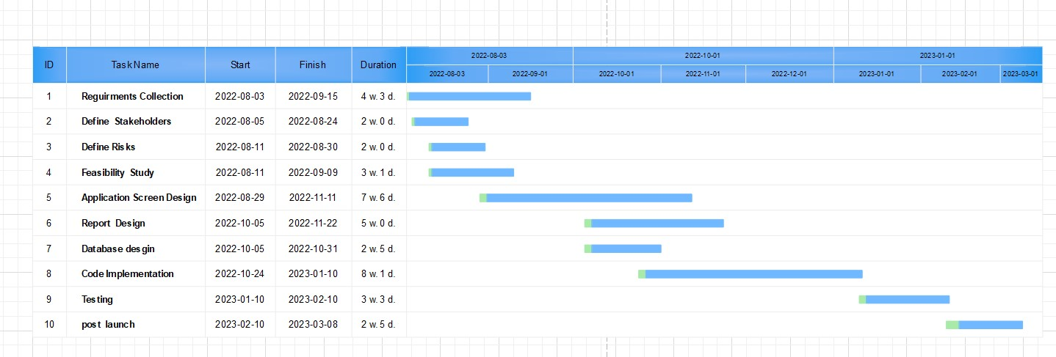

**Pert Calculation:**

|  |  |  |
| --- | --- | --- |
| **ACTIVITY** | **TIME ESTIMATE**  **o              r              p** | **EXPECTED TIME(ET)**  **O+4r+p** |
| **Requirement Collection** | **1            4             7** | **24** |
| **Define Stakeholders** | **1              2             6** | **15** |
| **Define Risks** | **1              2         4** | **13** |
| **Feasibility study** | **1              3             9** | **18** |
| **Application Screen Design** | **4            7        12** | **44** |
| **Report Design** | **2              5            10** | **32** |
| **Database Design** | **1              2             8** | **17** |
| **Code Implementation** | **3              8            11** | **46** |
| **Testing** | **2              3             5** | **19** |
| **Post launch** | **2              2             4** | **14** |

**PERT Chart:**

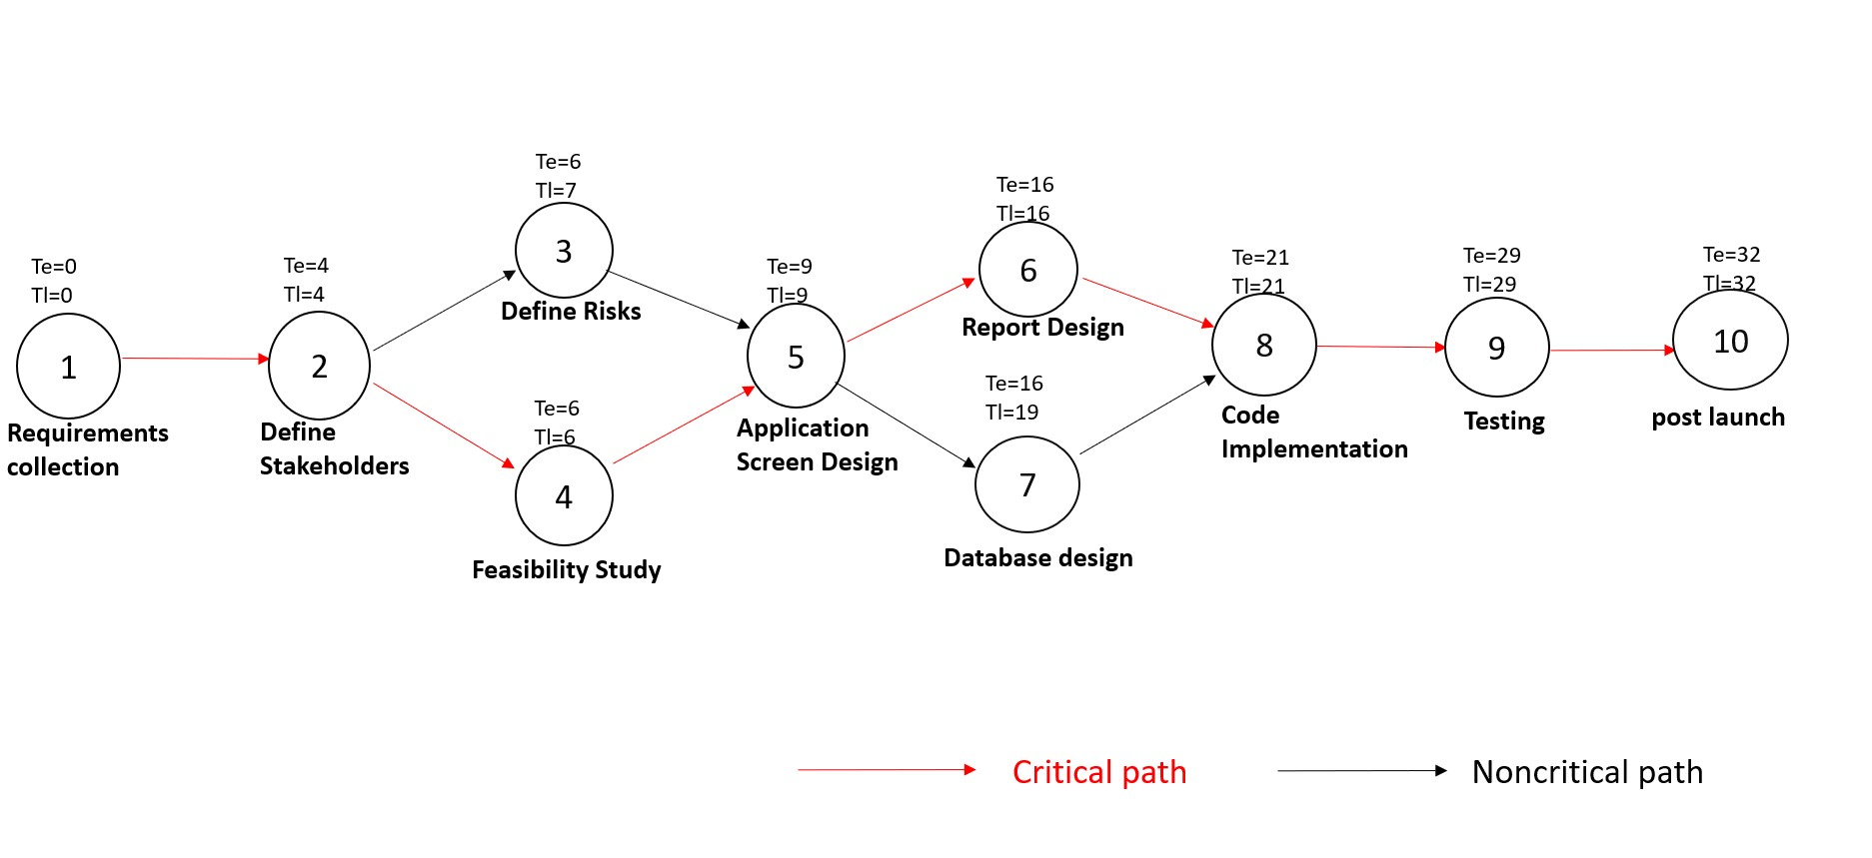

**Critical path – Slack Time**

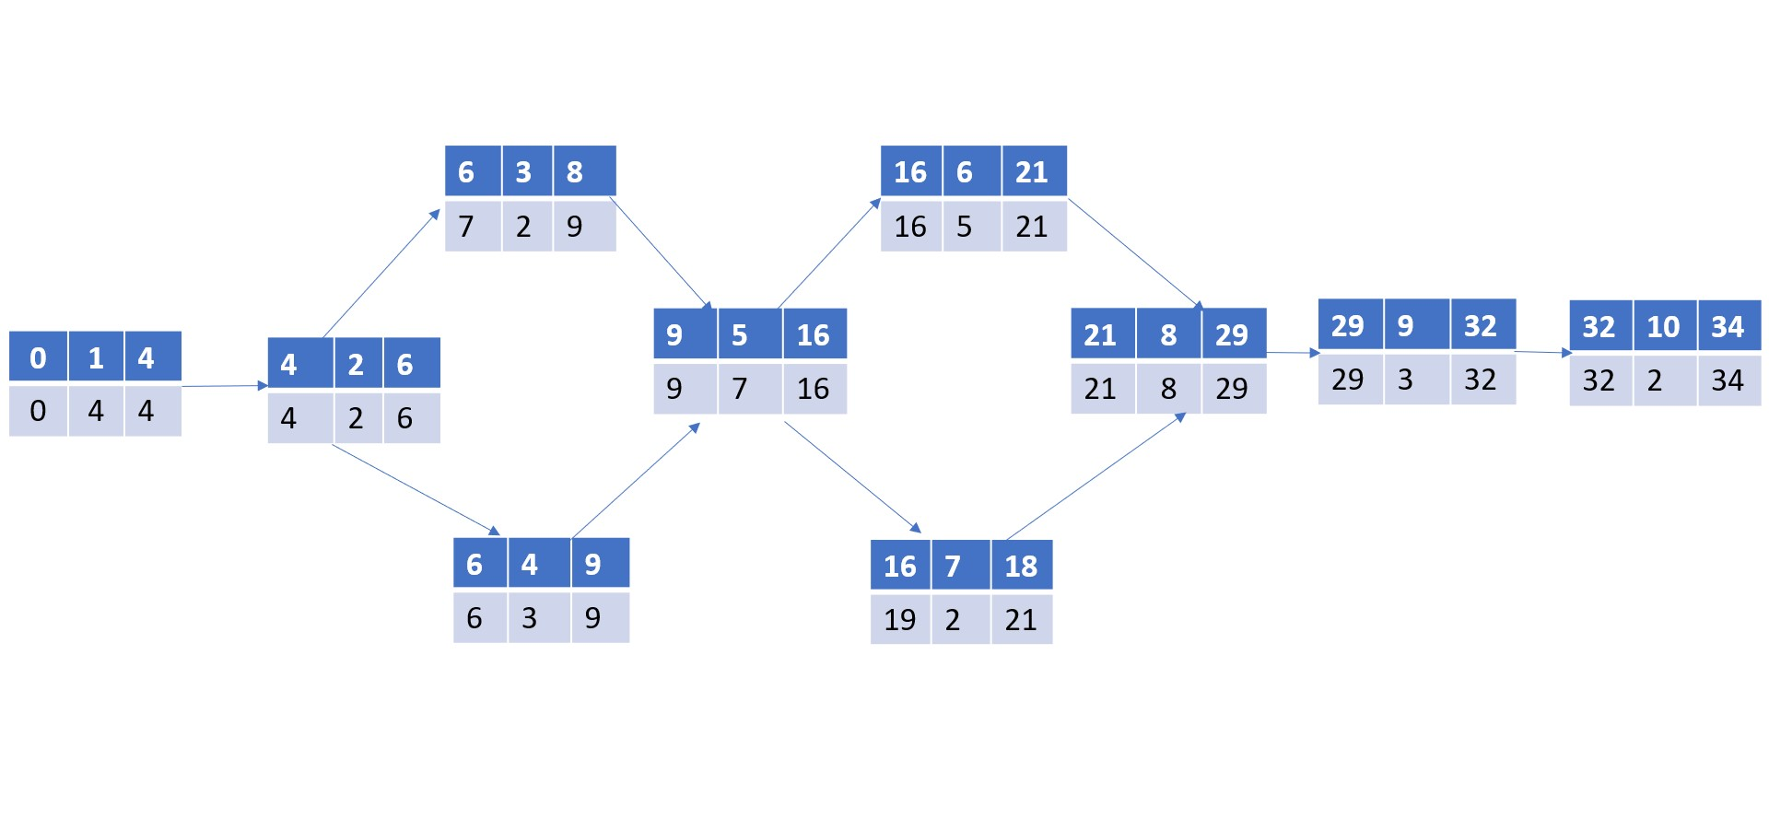**--------------------------------------------------------------------**

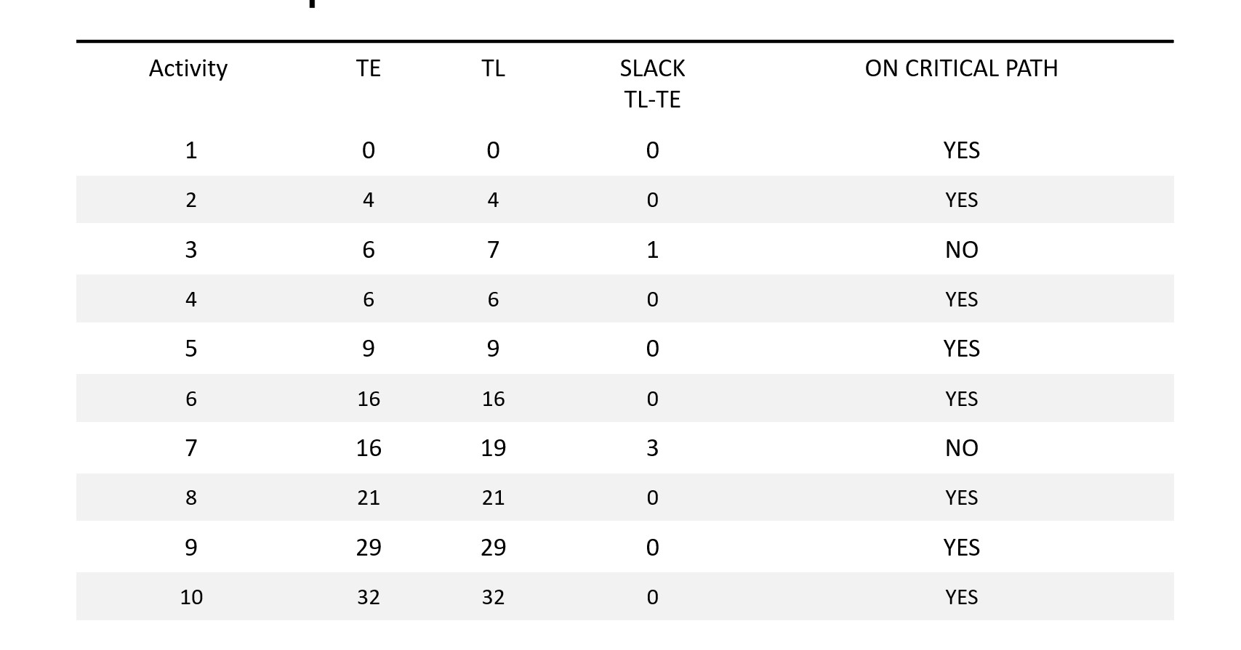**Critical path – Slack Time (Table)**

**-----------------------------------------------------**

**Table of contents:**

2. Analysis phase2:

2.1. Techniques..........................................................3

  2.2.functional and non-functional requirements.......4

2.3. Context Diagram..................................................6

2.4. Data Flow Diagram (DFD)....................................7

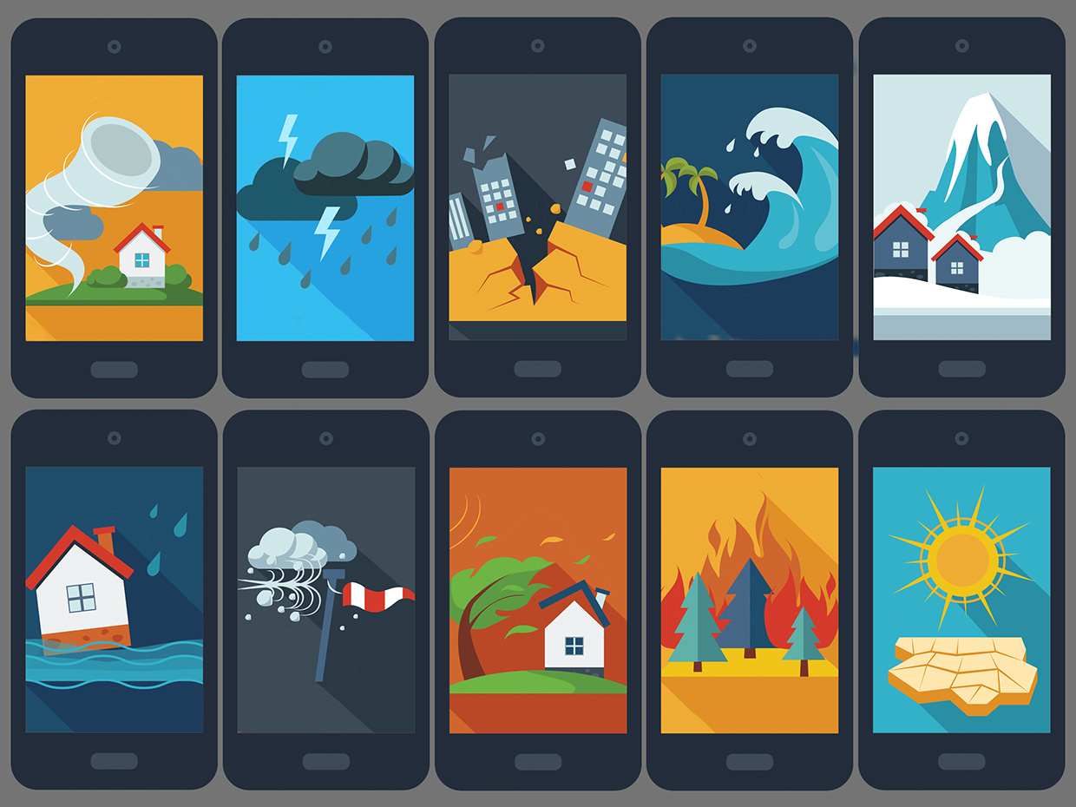 2.5. Decision Table......................................................9

**2.1. Techniques:**

Technique #1: Interviewing:

The project manager interviews the stakeholders about their needs in the project.

### Technique #2: Observation:

### A potential user of the product is watched to identify requirements.

### Technique #3: Prototypes:

### A model of the proposed product is developed and then this model is presented to stakeholders for feedback.

**2.2. functional requirements:**

1. The application will be able to notify the user with every possible disaster that could happen in their place.
2. When a user enters data, the system should send an approval request.
3. The police and the ambulance emergency will be able to come to the user at any time under any circumstances.
4. The application will be also able to tell the user when will the help come to his location and how much it will take.
5. The user can choose the application language.
6. The system gives a detailed and simple information about how to use the application.
7. The user has to enter his/her information and verify it.
8. Giving information about track of storms and intensity of rains and any possible weather conditions.
9. The system should shut down in the event of a hacker attack

**2.2. non functional requirements:**

1. Availability:

a. The application will be always available 24/7 and under any conditions.

b. The application will always have connection with user anywhere.

1. Security:

User information are secure, and no one will be able to access it.

1. Safety:

User info are also safe from any viruses and hackers.

1. Useability:

The system shall be easy to use for any age.

1. Reliability:

The system is supported by data security and by main server in the application.

1. **Scalability :-**

The App should be able to adopt itself to increased usage or able to handle more data as time progress.

**2.3. Context Diagram:**

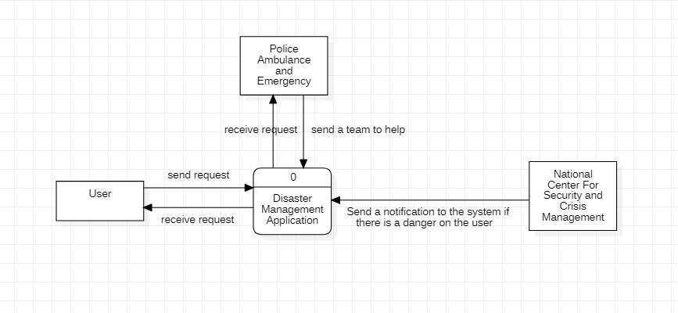

**2.4. Dfd level-0:**

**2.4. Dfd level-1:**

**2.5. Decision Table:**

|  |  |  |  |  |  |
| --- | --- | --- | --- | --- | --- |
| **Conditions/ Courses of Action** | **Rules** | | | | |
| **1** | **2** | **3** | **4** | **5** |
| **Requester is authorized** | **F** | **T** | **T** | **T** | **T** |
| **Police is available** | **-** | **F** | **T** | **T** | **T** |
| **Emergency is available** | **-** | **-** | **F** | **T** | **T** |
| **National center is working** | **-** | **-** | **-** | **F** | **T** |
| **Action** |  |  |  |  |  |
| **Accept request** |  |  | **X** | **X** | **X** |
| **Reject request** | **X** | **X** |  |  |  |

F => False

T => True

**Table of contents:**

Phase 3: **Design and implementation**

**3.1 ER Diagram...............................................33**

**3.2 The type of testing in the program.………….34**

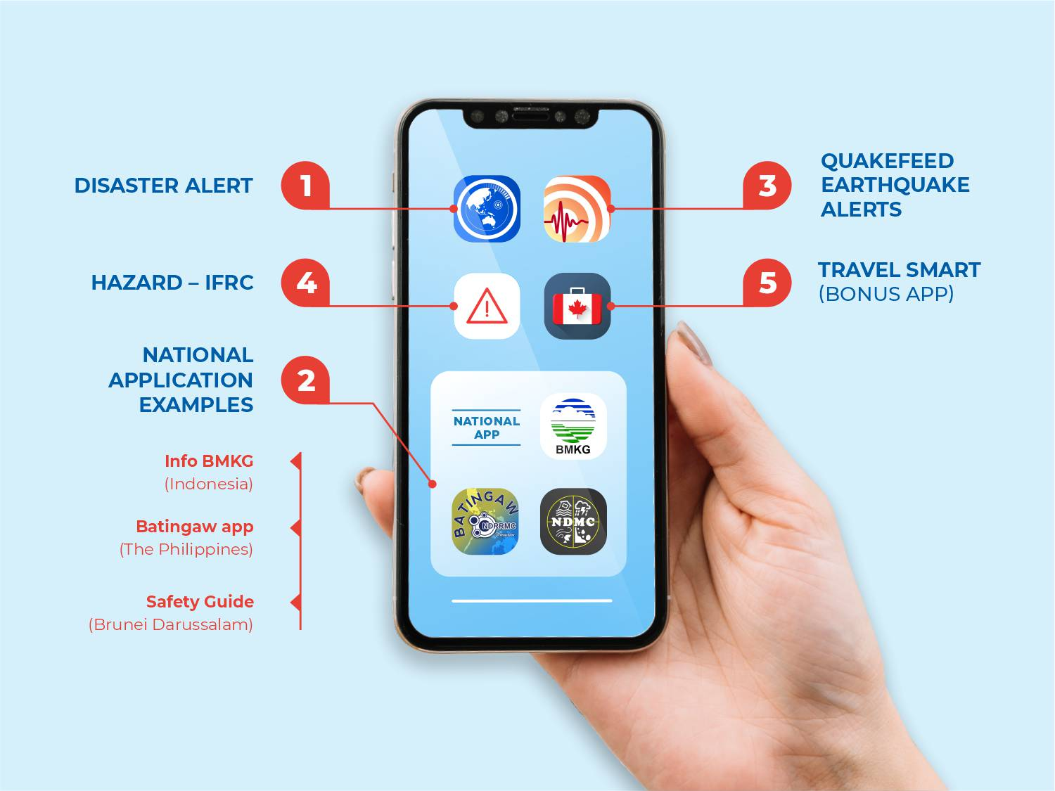

**3.1. ER Diagram:**

**3.2. Type Of Testing:**

**1-Testing Non-Functional Requirements:**

Ease to use: Test by asking several people to use the features of the system.

**2- Security & Privacy:**

Try hacking into the system's database and extracting user information.

**3-Reliability:**

Making a huge number of requests to the system at same time

**4- Testing Functional Requirements:**

-Test if the system will be able to take the weather report as an input or not.

-Check if the system be able to notify the police ambulance and emergency.

-be able to notify the user about any possible conditions.